--------------GROUP MEMBERS-------------

CHANDRAKANT KESHARI (ID 12140500)

VIKASH SAMOTA (ID 12141750)

ARNAB DAS (ID 12140270)

HIMANSHU SOUMYA LAKRA (ID 12140790)

KUNAL SINGLA (ID 12140960)

Using two Arduino one for sending square pulses and another for receiving the pulses

Transmitter Arduino code

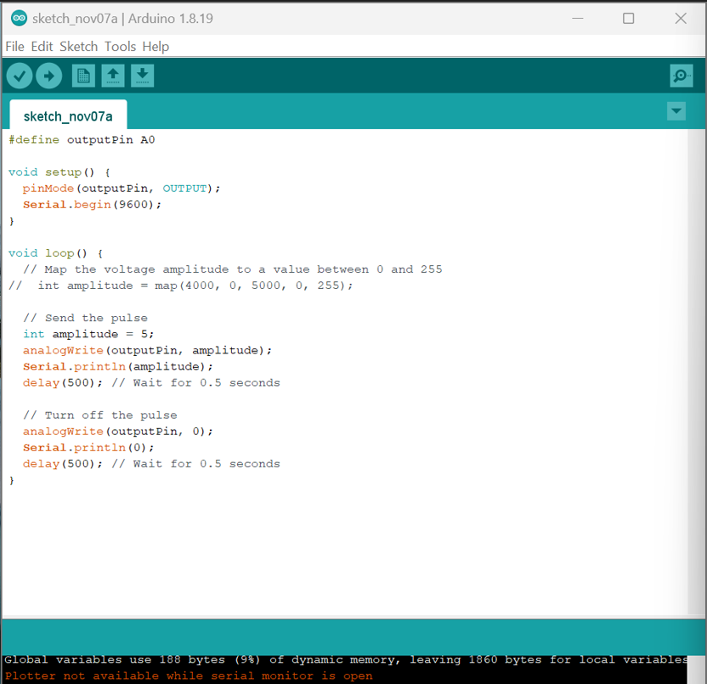

Input wave form

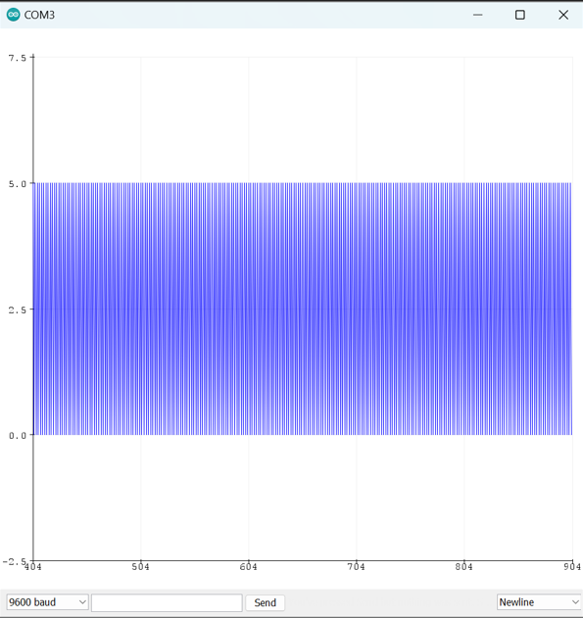

Receiver Arduino code

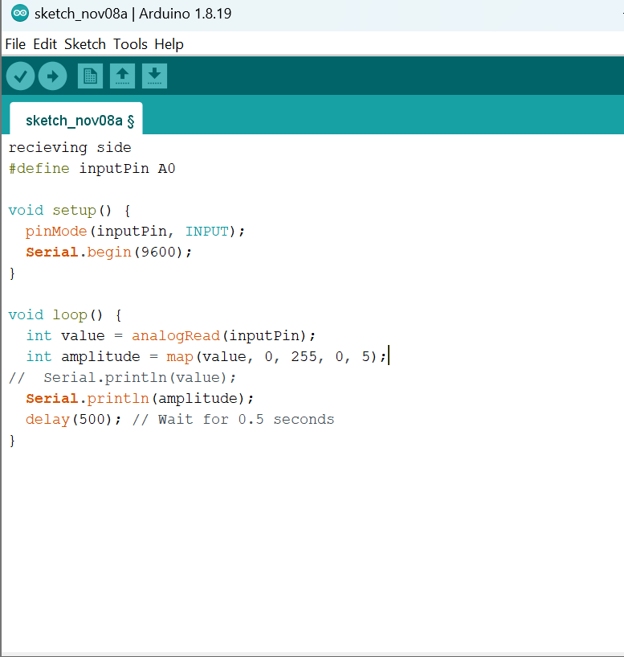

Output waveform

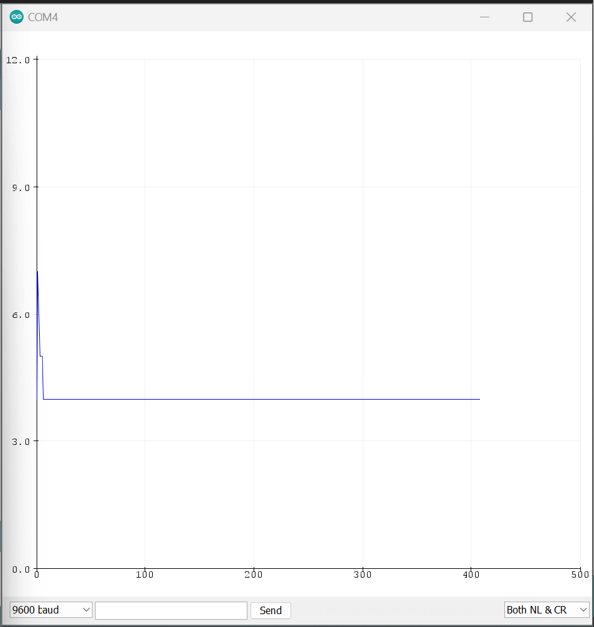

Using single Arduino

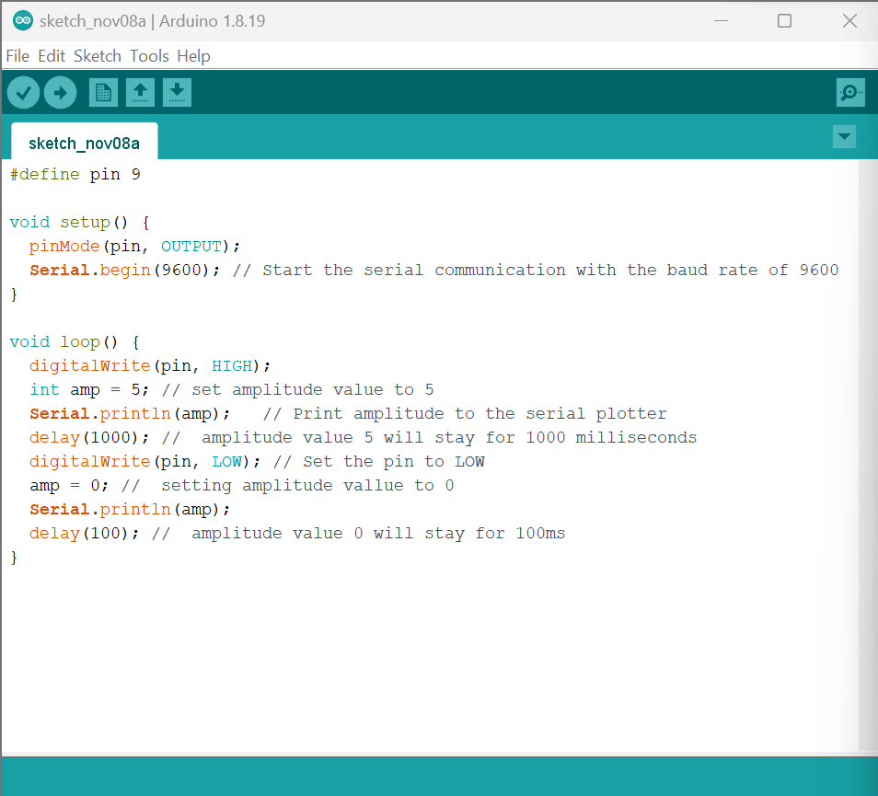

Code for generating square wave

wave form on serial plotter

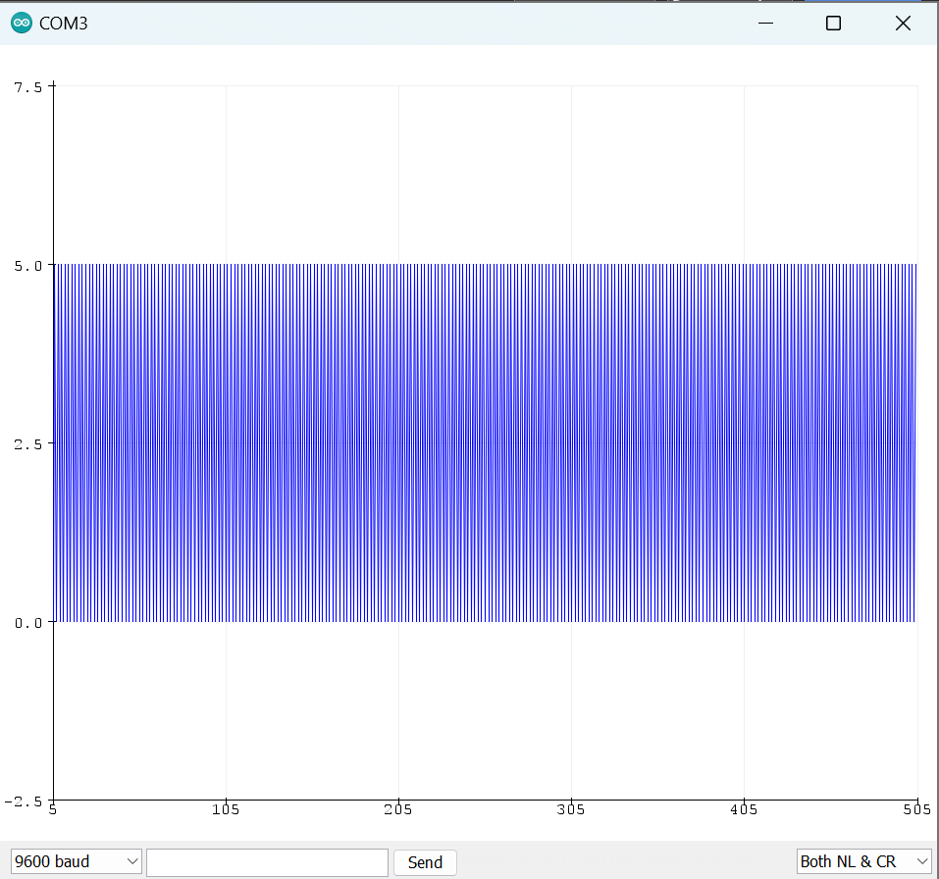

Output on oscilloscope

